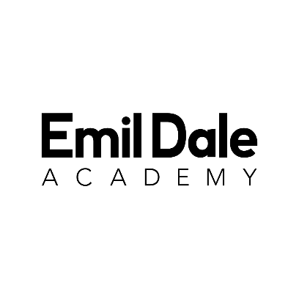

Fee Payments, Debt Collection & Refunds Policy

Table of Contents
Glossary 3
1. Scope 5
2. Policy 6
3. Important Information 7
3.1 Table 1: Fees Per Course 7
3.2 Partnerships and associated fees 8
3.3 a) North Hertfordshire College Students – government fee provision 8
3.3 b) University of Bedfordshire – Degree and Cert-HE fees 8
4. Private Sector Hours 10
4.1 Fees for Private Sector Hours 10
5. Acceptance of Place & Cooling Off Period 12
6. Invoicing and Payment 13
6.1 Payment milestones 13
6.2 Receipt of Invoices 13
6.3 When payment is due for the private sector for each course (“Payment Milestones”) 14
6.3.1 Table 2: ENTRY SEPTEMBER 2026: 14
6.3.2 Table 3: ENTRY SEPTEMBER 2025: 15
6.4 Fee Payment Terms (Private Sector Fees) 16
6.5 Advance Payment of Fees 17
6.6 Non-Refundable Circumstances 17
6.7 Availability of Provision 18
6.8 Discretionary Support 18
6.9 Exceptional Circumstances 18
6.10 Fee Payment Terms (University Tuition Fees Payments) 18
7. Payment Methods 19
8. Debt Collection 20
8.1 Returning students with debt 20
8.2 Late payment charges 20
9. Withdrawing from the Course 21
9.1 Table 4: WITHDRAWAL DATE & PRIVATE SECTOR FEE LIABILITY 21
9.2 Intermittent Study/ Opting Out of Private Sector 22
9.2.1 For students on the three year course: 22
9.2.2 Payment Requirements – Three year course 22
9.2.3 Participation Requirements – Three year course 22
9.2.4 For students on the one year course: 22
9.2.5 For students on the 2 year course: 23
10. Scholarships 24
11. Refunds 25
11.1 Cancellations (after the cooling-off period) 25
11.2 Complaint Remedies 25
11.3 Refund or waiver of fees 25
11.4 Payment of refunds 26

Glossary
Term | Definition
Private Sector Hours | Additional classes offered by Emil Dale Academy that supplement qualification-based teaching but are not part of the accredited course units. These classes are provided by EDA independently and are subject to private sector fees.
Private Sector Fees | Fees charged by Emil Dale Academy for participation in Private Sector Hours, separate from tuition fees payable to partner institutions.
Tuition Fees | Fees payable directly to a validating partner institution (e.g., University of Bedfordshire, North Hertfordshire College) for the accredited qualification element of a course.
Deposit | A non-refundable payment made to confirm acceptance of a place on a course, unless withdrawn within the cooling-off period or if a place is not granted.
Cooling-Off Period | The 14-day period following acceptance of an offer during which a student may cancel their place and receive a refund of any payments made, in line with the Consumer Contracts (Information, Cancellation and Additional Charges) Regulations 2013.
Payment Milestones | The agreed dates by which specified instalments of private sector fees must be paid.
Invoice | A formal request for payment issued by Emil Dale Academy detailing the amount owed, due date, and payment method.
Fee Payer | The person responsible for making payments to Emil Dale Academy on behalf of a student. This may be the student themselves or a third party such as a parent or guardian.
Outstanding Balance | The remaining amount of fees due that has not yet been paid by the student or fee payer.
Late Payment Charge | An administration fee or interest applied to accounts where payment is not received by the due date.
Debt Collection Agency | An external organisation authorised by Emil Dale Academy to recover unpaid fees on its behalf.
Payment Plan | An agreed schedule allowing a student or fee payer to pay private sector fees in instalments over the academic year.
Refund | The repayment of money previously paid to Emil Dale Academy, subject to eligibility under this policy.
Withdrawal | The formal process by which a student ends their enrolment on a course before completion.
Intermission / Intermittent Study | A formally approved break from study, usually for medical, financial, or personal reasons, with the intention to return later.
Fee Liability | The proportion of total fees that a student remains responsible for paying, depending on their withdrawal date or attendance.

University of Bedfordshire (UoB) | The validating higher education institution that awards the CertHE and BA (Hons) Musical Theatre qualifications delivered at Emil Dale Academy.
North Hertfordshire College (NHC) | The further education partner institution that validates and funds Year 12 of the BTEC Level 3 course at Emil Dale Academy.
BTEC | The Level 3 National Extended Diploma in Performing Arts Practice (Musical Theatre) qualification awarded by Pearson and delivered in partnership with NHC.
CertHE | The Certificate of Higher Education in Musical Theatre Performance awarded by the University of Bedfordshire.
BA (Hons) | The Bachelor of Arts (Honours) in Musical Theatre awarded by the University of Bedfordshire.
Scholarship | A discretionary reduction or waiver of private sector fees awarded by Emil Dale Academy based on talent and/or financial need.
Agent Panel Day / London Showcase | Industry-facing events for final-year degree students to perform in front of professional agents and industry representatives, subject to eligibility and payment of private sector fees.

Consumer Rights Act 2015 | UK legislation ensuring that contractual terms with consumers, including students, are fair and transparent.
CMA (Competition and Markets Authority) | The UK regulator that provides guidance for higher education providers on fair terms and conditions for students.
GDPR / UK GDPR | Data protection legislation governing how Emil Dale Academy collects, uses, and protects personal and financial information.
Anti-Money Laundering (AML) Laws | UK laws preventing financial crime by ensuring refunds are only made to the original payer.
Force Majeure | Events outside of Emil Dale Academy’s reasonable control that prevent normal operations (e.g., pandemic, strike, or natural disaster).
Offer Letter / Offer Pack | The formal written offer from Emil Dale Academy outlining the terms of admission, course details, and fee obligations.

1. Scope
- This policy is applicable to all of Emil Dale Academy’s students who participate in the Private Sector hours on any of the full-time courses at Emil Dale Academy.

- This policy does not have any bearing on the BA (hons) or Cert-HE provisions with the University of Bedfordshire or the BTEC programme with North Hertfordhire College, which is governed by a separate contract between the partner and Emil Dale Academy. For the purposes of such programmes of study, students are enrolled as the University of Bedfordshire or North Hertfordshire College students, as the case may be.

- We work in partnership with the University of Bedfordshire and North Hertfordshire College in respect of the delivery of their programmes of study. Therefore, any monies used to pay for those respective courses and paid directly to those partners will require students and their families to follow the applicable refund policies through those institutions.

- All courses at Emil Dale Academy have fees attached to them which cover private sector hours. All fees are inclusive of VAT (VAT number: 136080728). This policy relates to Private Sector fees at Emil Dale Academy.

2. Policy
- The prompt payment of fees is integral to the running of Emil Dale Academy.

- The aim of this policy is to ensure a robust, non-discriminatory, and fair approach to the methods by which fees are paid and how Emil Dale Academy approaches those who have not paid fees on time.

- EDA aims to be as transparent as possible with fee streams and charges made to students, and the expectations for payment. EDA complies with the UK Consumer Rights Act 2015 and the Competition and Markets Authority (CMA) guidance for higher education providers to ensure students receive clear, fair, and transparent terms.

- The objective of this policy is to ensure there is consistency in terms of approach and methodology. It is imperative that a standard process exists and that all involved are aware of this.

- Students will be asked to agree to the terms of this policy as part of the registration process at the start of the course with EDA; anyone that does not agree to their fee payment terms will be unable to participate in the relevant classes until an agreement has been made and signed for.

- For the avoidance of doubt, when someone signs an agreement for applicable fees at the start of their course, this agreement remains in place for the duration of their study/course at Emil Dale Academy.

- The Business, Compliance & Strategy Manager or their nominee has responsibility for managing the processes associated with fee liability for students and the financial liability for students who may withdraw or intermit.

3. Important Information
- At Emil Dale Academy, the three courses offered are:
- 1 Gap Year with Cert-HE in Musical Theatre Performance
- 2 Year Sixth Form Course with BTEC Level Three National Extended Diploma in Performing Arts Practice (Musical Theatre)
- 3 Year Course with BA (Hons) in Musical Theatre
- Tuition fee payments for your programme of study will be set out in your offer letter.
- Fee payments are liable for all courses, as explained here:

3.1 Table 1: Fees Per Course
Course | Partnership Fee for 2027-2028 (as known at the time of publishing) | Partnership Fee for 2026-2027 | Partnership Fee for 2025-2026 | Private Sector fee
1 Year Cert-HE in Musical Theatre Performance | £9790 for 2027-2028 academic year  Paid privately or through Student Loan Company (applied for by the student) | £9790 for 2026-2027 academic year  Paid privately or through Student Loan Company (applied for by the student) | £9535 for 2025-2026 academic year  Paid privately or through Student Loan Company (applied for by the student) | September 2027 enrollment: £1900 per year  September 2026 enrollment: £1750 per year  September 2025 enrollment: £1750 per year
2 Year Sixth Form Course with BTEC Level Three National Extended Diploma in Performing Arts Practice (Musical Theatre) | Government funded; directly from ESFA | Government funded; directly from ESFA | Government funded; directly from ESFA | September 2027 enrollment: £4900 per year  September 2026 enrollment: £4600 per year  September 2025 enrollment: £4450 per year
3 Year Course with BA Hons in Musical Theatre | £9790 for 2027-2028 academic year  Paid privately or through Student Loan Company (applied for by the student) | £9790 for 2026-2027 academic year  Paid privately or through Student Loan Company (applied for by the student) | £9535 for 2025-2026 academic year  Paid privately or through Student Loan Company (applied for by the student)  (Students who enrolled on the degree course in September 2023 or 2024 pay £9250 to the university) | September 2027 enrollment: £3900 per year  September 2026 enrollment: £3600 per year  September 2025 enrollment: £3450 per year  September 2024 enrollment: £3300 per year

- Note, partnership fees are to be paid directly to the partner, and EDA receives a percentage of the fees to deliver the course from the partner – students are not involved in that part of the transaction between EDA and partner.
- EDA may increase fees each academic year, but will not increase fees mid-year.

3.2 Partnerships and associated fees
17. Emil Dale Academy (EDA) works in partnership with North Hertfordshire College for the BTEC Level 3 National Extended Diploma in Performing Arts Practice (Musical Theatre), and The University of Bedfordshire (UoB) for the BA Hons in Musical Theatre degree course and Cert-HE in Musical Theatre Performance course.
3.3 Explanation of Partnership arrangements with Emil Dale Academy
18. Emil Dale Academy has formal partnership agreements with their partners.
19. EDA acts as a subcontractor to those partners. This means EDA delivers the teaching of the relevant qualification (BTEC, Degree or Cert-HE) and they are a study centre of the partner. The partners are responsible for ensuring quality of the courses offered at EDA and they validate the qualifications.
20. The students in turn receive benefits of being enrolled and registered as students of the relevant institution.
21. Essentially, EDA is a remote campus of each partner for the relevant qualification. Any fees associated with each qualification are paid directly to Nort Herts College or the University of Bedfordshire, and they then provide a percentage of this to EDA for the teaching of the course.

3.3 a) North Hertfordshire College Students – government fee provision
22. For students of North Herts College (NHC), there is a government provision paid directly to NHC which the student is automatically entitled to. There is no need to apply for this; this money is paid directly to NHC from the government.

3.3 b) University of Bedfordshire – Degree and Cert-HE fees
23. For students of the University of Bedfordshire, the national standard fee is applicable to be paid directly to the University of £9790 per academic year (correct at the time of publish)
24. Students have to arrange this payment themselves, and this can be done either privately (self-funded) or through the Student Loan Company accessible to them (*note there are different student loan companies to apply to depending on whether you reside in England, Scotland, Wales or Northern Ireland).
25. If fees are being paid by a relative or friend of the student this is not considered as formal sponsorship; In this instance a student will be regarded as self‐financing.
26. These fees do not qualify for any Emil Dale Academy scholarships, however some bursaries may apply through the University.
27. For more information on University of Bedfordshire fees, please visit: www.beds.ac.uk/howtoapply/money/fees/ and read their fee policy here: www.beds.ac.uk/media/bgfa1z4n/tuition-fees-policy.pdf
28. Once the University receives payment from the Student Loan Company or privately, they retain a percentage of this money and a percentage is paid to EDA to deliver the degree course.
29. In addition to the qualifications offered, EDA offers a range of Private Sector Hours which wrap-around the qualification units and classes which incur different fees, as explained in section 4 of this policy.

4. Private Sector Hours
30. The 2 Year Course offers a BTEC Level Three Extended Diploma in Performing Arts (Musical Theatre) qualification, which is taken in partnership with North Herts College (NHC).
31. For these specific classes and units that each student is enrolled in, they do so as students of NHC.
32. In addition to the BTEC-specific classes and units, there are classes offered within this programme which are private sector classes and do not contribute to the BTEC qualification. This means that you do not have to complete these classes to complete the BTEC qualification.
33. The 3 Year Course offers a BA Hons in Musical Theatre, and the 1 Year Course offers a Cert-HE in Musical Theatre Performance, both of which are taken in partnership with The University of Bedfordshire.
34. For these specific classes and units that each student is enrolled in, they do so as students of the University of Bedfordshire and as such are governed by their policies and procedures for these specific units.
35. In addition to the degree-specific classes and units, there are additional classes offered within this programme which are private sector classes and do not contribute to the degree or Cert-HE qualification. This means that you do not have to complete these classes to complete the degree or Cert-HE qualification.
36. The reason for these Private Sector Hours is that the BTEC qualification, Cert-HE and Degree qualification do not provide all of the skills required for a career in the demanding and competitive industry of musical theatre.
37. These additional skills will enable students to audition for higher education courses from the BTEC, and audition for professional work with skills needed for a career in musical theatre.
38. For the avoidance of doubt, if a student is on the 2 Year programme, they will be registered as an NHC student for the BTEC qualification, and if they are on the 1 Year or 3 Year programme they will be registered as University of Bedfordshire students for the qualifications.
39. For all other classes that they participate in, they are EDA students taking the private sector classes.

4.1 Fees for Private Sector Hours
40. Below the fee payments applicable to each of the three full-time courses available at Emil Dale Academy.
4.1.1 Cert-HE / Gap Year: £1900 per academic year
41. The fees for studying the Cert-HE programme in partnership with the University of Bedfordshire are £9,790 per year.
42. This covers all of the education and support required to complete the University of Bedfordshire Cert-HE programme.
43. This can be paid through a student loan scheme, or privately, and is paid directly to the University of Bedfordshire.
44. In addition, Emil Dale Academy offers a range of additional private sector hours to provide exposure to professional musical performance and to enhance opportunities for your progression and career. These are associated with an additional £1,900 charge per year.
4.1.2 Sixth Form (BTEC): £4900 per academic year for private sector hours*
45. Through our partnership with North Hertfordshire College (NHC), students are able to achieve a BTEC Level 3 National Extended Diploma in Performing Arts Practice (Musical Theatre).
46. In addition, Emil Dale Academy offers a range of additional private sector hours to provide exposure to professional musical performance and to enhance opportunities for your career. These hours are associated with the £4,900 charge per academic year.
47. The private sector hours do not form part of the BTEC qualification and therefore are not mandatory in order to gain the full qualification.
4.1.3 Degree: £3900 per academic year for private sector hours*
48. The fees for studying the BA (Hons) programme in partnership with the University of Bedfordshire are £9,790 per year.
49. This covers all of the education and support required to complete the University of Bedfordshire degree programme.
50. This can be paid through a student loan scheme, or privately, and is paid directly to the University of Bedfordshire.
51. In addition, Emil Dale Academy offers a range of additional private sector hours to provide exposure to professional musical performance and to enhance opportunities for your career. These are associated with an additional £3,900 charge per year.
* Fees correct at the time of policy issue (29th April 2026)

52. For more information on the classes covered by the Private Sector, please refer to the Teaching, Learning & Assessment Policy.

5. Acceptance of Place & Cooling Off Period
53. Students will be offered a place at Emil Dale Academy either by way of an offer box or pack in the post, or via email.
54. In order to confirm their place, they will be required to pay a £300 deposit towards private sector fees, within a specified time frame (detailed in the offer letter).
55. Upon paying the deposit for the private sector, students will enter a contract with EDA that ensures EDA will guarantee them a place on the course that they have successfully auditioned for.
56. This payment also is a confirmation that that student accepts the terms and conditions of EDA.
57. EDA reserves the right to amend or withdraw an offer where:
(a) the student does not meet the conditional offer of a place;
(b) it comes to our attention that the student (or party authorised to act on behalf of the student) provides fraudulent or false information, or has not disclosed information that would affect the decision of EDA to offer a place to them;
(c) it is considered on justifiable grounds that the students is unsuitable for a place on a particular programme according to individual circumstances, in particular where they have failed to abide by our rules and regulations, or the law;
(d) the student does not accept their offer within the specified time period set out in their offer letter.
58. After they have accepted a guaranteed place to study with us, the student will have a 14-day cooling off period from the date EDA receives their acceptance.
59. If the student wishes to decline the offer of the place during the 14 days, they must notify the EDA Office, setting out in writing your decision to withdraw and there will be a form to complete.
60. Any payments already made to EDA will be refunded within this 14 days, providing the appropriate bank details are provided or card refund can be processed through the card machine.
61. If the student’s programme of study starts before the end of the 14-day cooling off period, they may still cancel the place on the programme of study.
62. However, as EDA will have already started to provide services to the student, EDA reserve the right to deduct from any refund or deposit a fair amount to reflect the services already provided to the student, to the date EDA was notified of the students wish to withdraw from the programme of study.
63. The student is permitted to withdraw from the chosen programme of study at any time and for any reason after the cooling off period. However, any fees or fines outstanding must still be paid. On withdrawing from a programme, registration is terminated.
64. For the avoidance of doubt, private sector deposits are not returned if students withdraw after places have been accepted, unless within this 14 day cooling off period and the commencement of the programme of study is not within this 14 day period.
65. If the student chooses to withdraw their place after the 1st July within the year prior to the start of the course that they have been offered and paid a deposit for the private sector from, they will be subject to paying the first term of fees.

6. Invoicing and Payment
66. For private sector hours, the offer letter will set out the details of the fees applicable to the programme of study.

67. Fees are inclusive of VAT.

68. The details of what is included in the fee are set out in the offer letter and on the website.

6.1 Payment milestones
69. Students will receive details of payment milestones in their offer pack including dates of payment, amounts of each dated payment and how to pay.

6.2 Receipt of Invoices
70. Each student/ nominated fee payer will receive an invoice within 1 month before the first payment date.

71. The student/ nominated fee payer will receive monthly emails with their updated invoice until such a point that the invoice is paid in full. Even if the fee payer is paying annually or twice annually, they will still receive the invoice monthly until the fee is paid in full.

When payment is due for the private sector for each course (“Payment Milestones”)

6.3.1 Table 2: ENTRY SEPTEMBER 2027:

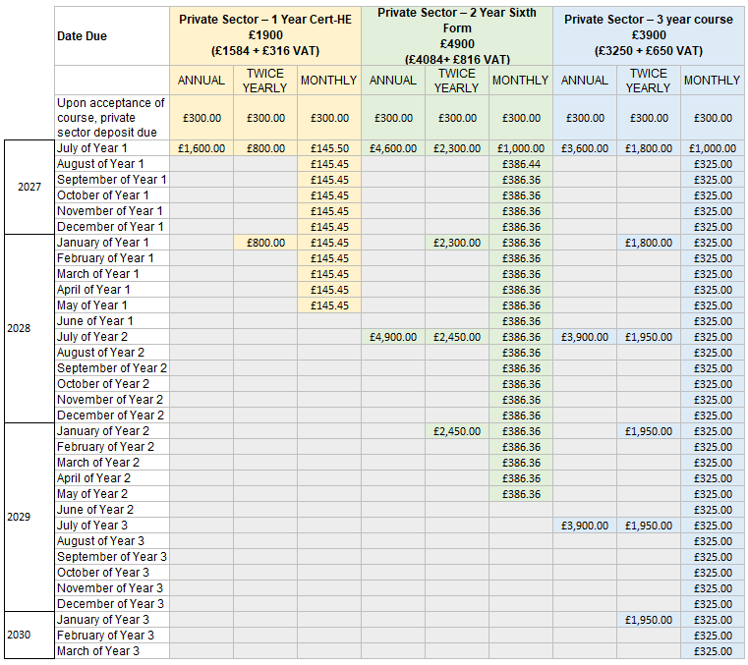

72. The above table demonstrates payments due from September 2026 per course.

6.3.1 Table 3: ENTRY SEPTEMBER 2026:

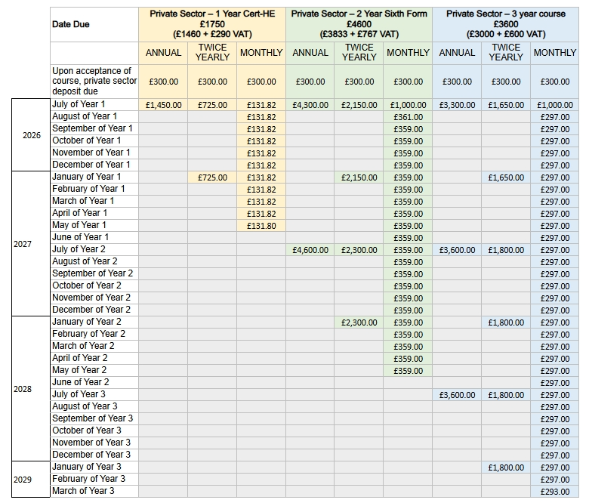

73. The above table demonstrates payments due from September 2026 per course.

6.3.2 Table 4: ENTRY SEPTEMBER 2025:

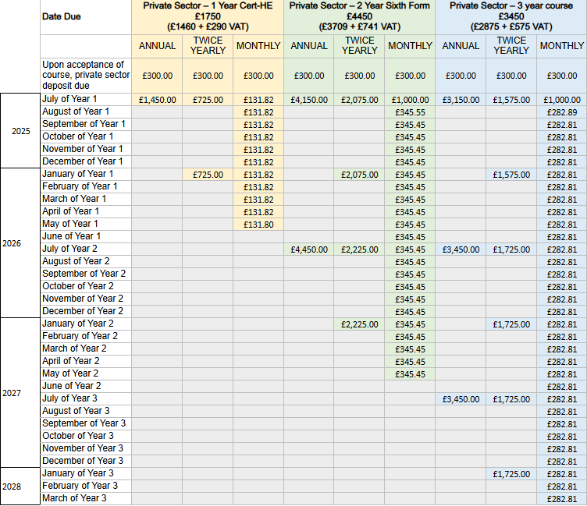

74. The above table demonstrates payments due from September 2025 per course.

6.4 Fee Payment Terms (Private Sector Fees)
75. Fee and funding details are based on the start date of the student’s programme of study as set out in their offer letter.
76. It is the student’s responsibility to make sure that the private sector fees, deposit (if applicable), or other expenses relating to the programme are up to date, and therefore are paid in full and on time. EDA’s contract is with the student. Where a third party (such as a parent or guardian) pays fees on behalf of a student, the student remains contractually liable for the full balance of fees owed.
77. The private sector deposit is non-refundable unless a place is not granted to you and subject to your cooling-off rights as provided for earlier in this policy.
78. EDA private sector fees may increase each year due to inflationary and other pressures. Students are advised to check the private sector fee for each year of their programme of study. Annual fee increases for existing students will not exceed the UK Consumer Price Index (CPI) plus 3%, unless justified by exceptional circumstances.
79. Students are expected to pay the private sector fees in accordance with payment due dates set out in their offer pack, unless they have come to a formal arrangement with EDA in writing to pay in more regular instalments or have a pre-agreed payment plan.
80. Students are expected to have made adequate provision for the payment of the private sector fees before arriving at EDA to study.
81. Students/ families should carefully note that the private sector fee does not include the tuition fee that is applicable for the university for their qualification, nor the fee that EDA can draw down through their BTEC partner.
82. Students/ families should carefully note that the private sector fee does not include charges for uniforms, kits, accommodation or subsistence costs, extensions to the programme, travel, field trips, visa costs, any applicable travel and medical insurance for placements or travel overseas, personal expenses, or other expenses that are related to the programme.
83. Please be aware there are additional costs (in addition to the fees payable for the programme of study) associated with being a student including uniform and equipment that is necessary for participation in the programme of study. Please contact the EDA Office for further details.
84. If a student does not keep up with their fee payments, this will affect their participation in productions and could impact their participation in Private Sector hours on their programme of study entirely. They may not be allowed to progress on the private sector of their programme of study, and it may lead to their withdrawal from private sector classes. In addition, EDA reserves the right to prevent the student from attending social events arranged by EDA or the private sector graduation ceremony if fees are unpaid.
85. EDA may also take legal action against the student to recover any unpaid fees or costs. Penalties for non-payment are set out on the EDA website. Where debts are referred to an external agency, the student/fee payer will be notified in writing before their details are shared. EDA will comply with the Data Protection Act 2018 and the UK GDPR when disclosing such information.
86. If a student withdraws from or interrupts their programme of study after it starts, they may be liable to pay the applicable private sector fees. Details are set out in the refund section of this policy (section 9).
87. There are different options for paying fees such as monthly, half-yearly or annually. The payment plan milestones must be adhered to.
88. Late fee payments will result in an administration fee being added to the account in accordance with the Debt Collection section of this policy (Section 8).
89. If a student chooses to apply for financial support privately to outside government or aid agencies to support the payment of private sector fees, this will not be accepted as a reason for any delay in paying the due fees to EDA.
90. No sibling discounts apply.
91. EDA will not be liable for any failure or delay in performing its obligations where such failure or delay is due to circumstances beyond its reasonable control (including but not limited to natural disasters, industrial action, pandemics, or government restrictions). In such cases, EDA will take reasonable steps to minimise disruption to teaching and learning. EDA reserves the right to teach lessons online, ensuring learning aims are met through this provision of study. There will be no reduction solely due to modality change where learning outcomes continue to be met.
92. EDA cannot accept liability for a payment not reaching their bank account due to the student/ fee payer quoting an incorrect account number or incorrect personal details. EDA does not accept liability if payment is refused or declined by the bank or credit/debit card supplier for any reason. If the card supplier declines payment, EDA is under no obligation to bring this fact to your attention. The student/ fee payer should check with their bank/credit/debit card supplier that payment has been deducted from their account.
93. If the student/ fee payer foresees any reason that fees cannot be paid on time, EDA advises them to contact the accounts department immediately by telephone 01462 677808 or email accounts@emildale.co.uk with ‘FAO Ann – {student name} FEES’ in the title. All fee issues are treated confidentially.
94. EDA reserves the right to request upfront payment of fees in the event that fee payments are frequently made late or are missed.
95. A nominated email address must be given for all fee notifications to be sent to. It is the student/ fee payers responsibility to check this email address regularly.
96. An up-to-date invoice will be issued monthly in advance of the next payment milestone; it is the students/fee payers responsibility to review the invoice to ensure the correct payment values/ dates have been captured on their account.
97. If the student/ fee payer is paying twice yearly or annually, they will continue to receive a monthly invoice until the invoice is paid in full.
98. The student/ fee payer will be notified via email of late payments. In the event of more than two (2) missed payments, EDA reserves the right to suspend the students’ access to private sector provision until payment has been cleared. EDA reserves the right to not teach any student who is not up to date with their fees.
99. If an item on the fee invoice is under query, the ‘undisputed’ balance of that fees invoice must be paid.

6.5 Advance Payment of Fees
100. Fees paid in advance, including but not limited to private sector fees, supplementary training, or additional provision beyond core academic programmes, are non-refundable.

6.6 Non-Refundable Circumstances
101. Where a student elects to pay fees in advance for future periods of study or training, such payments are made at the student’s own discretion and risk.
102. No refunds (in whole or in part) will be issued in circumstances including, but not limited to:
- Injury, illness, or medical conditions (temporary or long-term)
- Physical or mental health issues
- Financial hardship or loss of income
- Changes in personal circumstances
- Reduced participation or inability to fully engage with training
- Voluntary withdrawal from some or all classes
- A decision not to continue with optional or supplementary provision

6.7 Availability of Provision
103. A refund will not be due where Emil Dale Academy continues to make the relevant training, classes, or provision available in accordance with published timetables and policies, regardless of whether a student is able to attend or fully participate.

6.8 Discretionary Support
104. Any adjustments to training, deferment of participation, or temporary flexibility offered due to injury or illness are provided entirely at the Academy’s discretion and do not constitute grounds for a refund of fees paid in advance.

6.9 Exceptional Circumstances
105. Refunds will only be considered where Emil Dale Academy is unable to deliver the contracted provision due to its own withdrawal of services or material breach of contract. Any such refund will be limited to the unused portion of fees and assessed on a case-by-case basis.

6.10 Fee Payment Terms (University Tuition Fees Payments)
106. The university tuition fee is £9790 per year at the time of this policy issue.
107. The university tuition fee is separate to the Private Sector fees at EDA.
108. The university tuition fee must be paid directly to the university, either directly through direct payment or through a student loan provision.
109. The student must apply for their student loan directly, EDA will not be part of this process as the loan is a personal loan to the student.
110. EDA does not provide any information or verification of student fee status to the student loan companies and therefore does not have any bearing on the maintenance loan (which is means tested).
111. Students should read, understand and abide by the Tuition Fees Policy set out by the university: www.beds.ac.uk/media/bgfa1z4n/tuition-fees-policy.pdf

7. Payment Methods
112. At the time of issue of this policy, EDA accepts payment by cash, BACS or all major credit/debit card (except AmEx).

BACS details are:
Emil Dale School of Performing Arts
Sort Code: 20-05-74
Account Number: 80499439

113. Card payments can be made over the phone by calling 01462 677808 or in person at Reception during working hours (normally 8.30am – 4.30pm, Monday - Friday).

114. Cash payments can be made to reception; no coin change for large payment amounts (notes only). Anything under £100 can be paid in smaller change.

115. EDA cannot be liable for late fee payments if you are unable to contact or make payment during working hours.

116. EDA does not accept cheque payments.

8. Debt Collection
117. If a student fails to pay their private sector tuition fees on time, various services such as access to tutorials, library services or rehearsal space/studio bookings may be withdrawn, and their enrolment on the private sector may be terminated.

118. If a student is unable to pay any fees or charges by the appropriate due date, they should contact EDA at the earliest opportunity by emailing accounts@emildale.co.uk.

119. If the financial circumstances of a student change after they start their course, then EDA will review this on a case-by-case basis. Note that documentary evidence to support a request will be required before it can be considered.
120. EDA politely asks that Students and families/ guardians are not to be offended when EDA asks for financial evidence of a situation – whilst this is private and will remain confidential with only those that need to know within the company, it is critical that EDA have all of the information to assess a situation fully and fairly. EDA does not receive any external bursaries, grants or beneficiaries to replenish any unpaid fees/ scholarship offerings, and as such there is not an endless pot of money to offer financial assistance. EDA will offer any financial assistance at their discretion and depending on availability of funds.
121. Any withholding of information may mean EDA is unable to address any finance issues with a student or their nominated persons.

8.1 Returning students with debt
122. Students with outstanding private sector fee debts from a previous academic year are not permitted to re‐ enroll on to private sector classes. All private sector fee debts must be paid in full before a student is able to return to undertake another year of study.
123. Note* if you are on the degree, CertHE or BTEC, you will still be able to participate in classes related to those qualifications providing that the university has confirmed payment of their fees.

8.2 Late payment charges
124. EDA reserves the right to add an administration charge of up to 10% to the student’s invoice for late payment. Late payment constitutes any payment made after the payment milestone dates listed in your offer letter. The 10% administration fee will be based upon the monthly fee payment option.
125. EDA reserves the right to charge interest on overdue amounts at the statutory rate (currently 8% above the Bank of England base rate) in addition to administration charges, where appropriate.
126. EDA reserves the right to chase and request fee payments as appropriate
127. If fees are not paid on time, EDA also reserves the right to refuse a student entry into private sector classes until such a time that fees are paid. In the event that payments continually are not made, EDA reserves the right to request upfront payment of fees.
128. If fee payments are still not met, EDA may enlist a debt collection agency on their behalf to retrieve fees or seek legal representation for fee debt recovery.

9. Withdrawing from the Course
129. Private sector course fee charges, for any self-financed element of fees, are determined on the basis of enrolment status and not actual attendance.
130. If a student stops attending, but has not formally withdrawn or intermitted their studies, they will be liable for self-financed tuition fees until the point in time that they officially notify EDA in writing to accounts@emildale.co.uk or the student’s course leader.
131. If a student decides to withdraw from a course, they must notify EDA in writing of their decision either by letter sent recorded delivery to Emil Dale Academy FAO {Course name} Course Leader, The Old Grammar School, Broadway, Letchworth Garden City, Hertfordshire, SG6 3PA or via email to accounts@emildale.co.uk and their course leader (jonathan@emildale.co.uk for 3 year course students, rachels@emildale.co.uk for 2 year course students and marina@emildale.co.uk for 1 year course students).
132. In the absence of written notification of withdrawal, a student shall be assumed to be in attendance and as such remain liable for the payment of tuition fees.
133. For the avoidance of doubt, fee payments must be made as follows from any course withdrawals:

9.1 Table 5: WITHDRAWAL DATE & PRIVATE SECTOR FEE LIABILITY

Confirmed Withdrawal Date | Private Sector Fee Liability
Within 14 days of formally accepting the place granted at Emil Dale Academy | £0/ 0%
After 14 days of formally accepting the place granted at Emil Dale Academy (unless the course has already started within this time frame in which case services used may still be charged for) | £300 deposit
On or after 15 days of formally accepting the place granted at Emil Dale Academy OR  On or after the first day of the Autumn term | 33% of that academic year
On or after the first day of the Spring term | 67% of that academic year
On or after the first day of the Summer term | 100% of that academic year

134. The first day of Autumn, Spring and Summer term refers to the first date of your programme which for most, but not all, will be the same as the published term dates.

135. Please note, if you are on the three year programme which includes the Degree programme, or one year programme that includes the CertHE and you are funding the course through student finance via a loan from the Student Loan Company (SLC), your withdrawal date will be reported to the SLC and your Tuition Fee Loan (& Maintenance if received) will be adjusted accordingly to reflect the correct liability and any interest accrued. This forms part of your agreement with the University of Bedfordshire. It is the student’s responsibility to formally withdraw from their programme of study with the University.

9.2 Intermittent Study/ Opting Out of Private Sector
136. In the event that a student must take a break during the duration of an academic year, fees will not be adjusted unless formal withdrawal takes place.
137. Participation in Private Sector Hours is subject to payment of the relevant fees as outlined in the annual Fee Schedule.
138. Students who choose not to participate in Private Sector Hours may opt out; however, this must be confirmed in writing with the Academy.
139. Students who choose not to participate in Private Sector Hours will be issued with a revised timetable reflecting only the qualification unit classes for which they are eligible. This timetable will vary each term depending on the academic units being delivered.
140. Participation in assessed components for the qualification that the students have signed up for is mandatory to meet qualification criteria. The Academy will ensure all students are able to complete these required elements and payment of private sector fees and participation in private sector hours has no bearing whatsoever on a student being able to complete their qualification.

9.2.1 For students on the three year course:
141. In the event that a student has not paid for 50%+ of the private sector classes by the start of their third year, they will not be eligible to participate in the London Agent Panel Day and the London Showcase.
142. Students should note that opting out of Private Sector Hours will result in a significant reduction in weekly contact hours and time spent on campus. For example, in Year 1, the majority of Private Sector Hours take place during Term 3. Therefore, students who do not participate in Private Sector Hours may have limited scheduled classes during this period.

9.2.2 Payment Requirements – Three year course
143. In order to be eligible to participate in Agent Panel Day and the London Showcase, students must have paid at least 50% of their Private Sector fees by the commencement of their third year of study.
144. Students who have not met this payment requirement will not be permitted to take part in these industry-facing events.

Participation Requirements – Three year course
145. If a student has not opted in to the Private Sector hours by the first half term of their second year, then it is at EDA’s discretion as to whether they will be allowed to participate in third-year industry opportunities such as showcase or agent day.
Continued participation in Private Sector Hours throughout the majority of the first and second year is expected in order to ensure readiness for third-year industry opportunities.
146. Non-attendance or non-engagement without valid reason may affect eligibility for participation in Agent Panel Day and/or the London Showcase.
147. The Academy recognises that extenuating circumstances (e.g., injury, illness, mental health or other mitigating factors) may affect a student’s ability to participate. In such cases, eligibility will be considered on a case-by-case basis by the Course and Management Teams regarding participation in third-year industry events.
148. The Academy reserves the right to make the final decision regarding participation in third-year industry events based on engagement, attendance, conduct, and overall preparedness.

9.2.4 For students on the one year course:
149. In the event that a student has not paid for 100% of their private sector fees by the final payment date, they will not be eligible to participate in the end of year revue show.
150. Students should note that opting out of Private Sector Hours may result in a significant reduction in weekly contact hours and time spent on campus, and they would not be eligible to participate in the end of year revue show.
151. The Academy will review any extenuating circumstances (e.g., medical or personal reasons) on a case-by-case basis.

9.2.5 For students on the 2 year course:
152. In the event that a student has not paid for 50% of their private sector fees by the 1st May of their first year, and 100% of their private sector fees by 1st May of their second year, they will not be eligible to participate in the annual musical in June each year. This production provides key performance experience and is part of the private sector hours offered at EDA.
153. Students should note that opting out of Private Sector Hours may result in a significant reduction in weekly contact hours and time spent on campus, and they would not be eligible to participate in annual musical.
154. The Academy will review any extenuating circumstances (e.g., medical or personal reasons) on a case-by-case basis.

10. Scholarships
155. At Emil Dale Academy, we believe people have a right to train if they demonstrate talent in an audition, regardless of their financial background. Therefore, we have a fund of money to be able to give out a number of scholarships for Private Sector fees (note* we are not able to give scholarships towards Degree/CertHE fees that go directly to the University).
156. To apply for a scholarship, candidates must email admissions@emildale.co.uk to be sent a form. The form must be completed fully, with necessary supporting documentation to be considered for a scholarship.
157. Scholarships are based upon means testing forms as well as audition scores. Each candidate is looked at very closely to determine the status of a scholarship.
158. EDA cannot guarantee a scholarship just because a scholarship form has been completed.
159. Scholarships are not reimbursed from an external agency/ beneficiary but rather come directly from Emil Dale Academy funds; thus we cannot provide financial assistance to everyone.
160. EDA scholarships are offered following successful audition and completion of the means testing form (see Scholarship Policy).
161. Other fee waivers and awards, including one-off payments to help students in financial hardship, may be offered at any point during the academic year on a case-by-case basis. Application for these can be made by contacting the Accounts department by email accounts@emildale.co.uk.
162. If a student has started the course, and their circumstances change or they are unable to afford the private sector fees, they can apply for a scholarship but it is unlikely any student will receive a scholarship part-way through a year as the funding pot will have been allocated for that academic year.
163. There is an expectation of students on scholarships to volunteer at EDA events, and their behaviour and conduct should always be that of an exemplary student. Our Scholarship Expecation Policy sets out expected behaviours from scholarship students (Scholarship-Expectation-Policy-v04-240910.pdf) which must be adhered to otherwise the scholarship offer may be retracted.

11. Refunds
For advance payments, see Sections 6.5–6.7.

11.1 Cancellations (after the cooling-off period)
164. In the event that a student withdraws after the 14 day cooling off period (see above for details), EDA reserves the right to retain the private sector deposit payment.
165. In the event that a student withdraws part way through the academic year, in the matter of the recovery of the fees, EDA will charge the student 33% of the annual tuition fee if the student withdraws during Term 1 and 15 days after their formal acceptance of their place at Emil Dale Academy, 67% if they withdraw during Term 2, and 100% if they withdraw during Term 3(see 9.1 Table 5).
166. Students will be liable for this fee payment regardless of the reason for withdrawing.
167. Where payment has been made in excess of the tuition fee charged (including non‐refundable deposits) overpayment refunds can be requested.
168. Demands for immediate refunds cannot be made. Refunds will only be issued once formal withdrawal from a course has been confirmed, and within 30 days of this approval being granted.

11.2 Complaint Remedies
169. Where a student submits an appeal or complaint, requesting a refund or compensation, it should be noted that financial compensation may not always be an appropriate response or agreed remedy when addressing a complaint or appeal.
170. Alternatives to financial compensation might include an apology or goodwill gesture, or an offer of alternative learning methods if the course cannot be delivered in the way it was originally intended.
171. A refund relates to the repayment of sums paid by a student to EDA or an appropriate reduction in the amount of sums owed in future by the student to EDA.
172. Compensation will relate to some other recognisable loss suffered by the student. This normally falls into two categories, either:
(a) recompensing the student for out-of pocket expenses they have incurred for a scheduled activity that did not take place, which were paid to someone other than EDA (such as travel costs) or
(b) an amount to recompense for material disadvantage to the student arising from a failure by EDA to discharge its duties appropriately.
173. Students should refer to EDA’s Student Complaint Policy and University of Bedfordshire’s Academic Appeals policy for in-depth information relating to Appeals and Complaints.

11.3 Refund or waiver of fees
174. Save where there is a legal liability under a court order or under the provisions of this agreement to make a refund, fees will not be refunded or waived if:
- The student is absent through illness; or
- A term is shortened or a vacation extended; or
- The government issues a bank holiday or shuts schools for any reason; or
- The student is released home before the normal end of the school day; or
- EDA is temporarily closed due, for example, to adverse weather conditions; or
- For any other reasonable reason.

11.4 Payment of refunds
175. In accordance with UK anti-money laundering laws, refunds can only be made to the person who originally paid the fee. In some cases, this will mean that the refund will be paid to someone other than the student, such as a parent/guardian/ sponsor.
176. Refunds will be paid by BACS or to the card originally charged, within 30 working days of a refund being approved.

Document Control
Version Number | Date of Issue | Review Date | Author | Changes Made/ detail
01 | 17.09.2020 | July 2021 | Sarah Moore | First draft
02 | 24.06.2022 | July 2023 | Sarah Moore | Amendment to bank account details and fees
03 | 07.08.2023 | July 2024 | Sarah Moore | Amendment to include reference to Cert-HE  More detail in each section
04 | 03/04/2024 | July 2024 | Sarah Moore | Change Gap Year fees to Cert-he and relevant costs
05 | 24th September 2025 | September 2026 | Sarah Moore | Update to terms  Update to fee payment milestones  Added all of 9.2 clauses  New format
06 | 21st January 2025 | July 2026 | Sarah Moore | Update to university fees and added refund clauses
07 | 29th April 2026 | July 2027 | Sarah Moore | Update to fees for 2027 entry, add link to scholarship expectations policy

